# VES 6.8.2 Over the Shoulder Test Results

## End-To-End Testing conducted with VOA Team on 2/27/2024.

**Test Scenario# 1**

Applicant selects YES for all the special factors for TERA from VOA (stagingva.gov app)

SQA-A ICN: 0000001013992927V124543000000

**Snippet of VOA Request received in VES**:

<ns0:specialFactors>

<ns0:agentOrangeInd>true</ns0:agentOrangeInd>

<ns0:envContaminantsInd>false</ns0:envContaminantsInd>

<ns0:campLejeuneInd>false</ns0:campLejeuneInd>

<ns0:radiationExposureInd>true</ns0:radiationExposureInd>

**<ns0:gulfWarHazard>**

**<ns0:gulfWarHazardInd>true</ns0:gulfWarHazardInd>**

**<ns0:fromDate>01/2000</ns0:fromDate>**

**<ns0:toDate>08/2001</ns0:toDate>**

**</ns0:gulfWarHazard>**

**<ns0:supportOperationsInd>true</ns0:supportOperationsInd>**

**<ns0:toxicExposure>**

**<ns0:exposureCategories>**

**<ns0:exposureCategory>Air Pollutants</ns0:exposureCategory>**

**<ns0:exposureCategory>Chemicals</ns0:exposureCategory>**

**<ns0:exposureCategory>Contaminated Water at Camp Lejeune</ns0:exposureCategory>**

**<ns0:exposureCategory>Radiation</ns0:exposureCategory>**

**<ns0:exposureCategory>SHAD</ns0:exposureCategory>**

**<ns0:exposureCategory>Occupational Hazards</ns0:exposureCategory>**

**<ns0:exposureCategory>Asbestos</ns0:exposureCategory>**

**<ns0:exposureCategory>Mustard Gas</ns0:exposureCategory>**

**<ns0:exposureCategory>Warfare Agents</ns0:exposureCategory>**

**<ns0:exposureCategory>Other</ns0:exposureCategory>**

**</ns0:exposureCategories>**

**<ns0:otherText>Toxins</ns0:otherText>**

**<ns0:fromDate>04/2002</ns0:fromDate>**

**<ns0:toDate>12/2005</ns0:toDate>**

**</ns0:toxicExposure>**

</ns0:specialFactors>

**Expected Result: PASS**

TERA Work item is created in VES. Screenshot below:

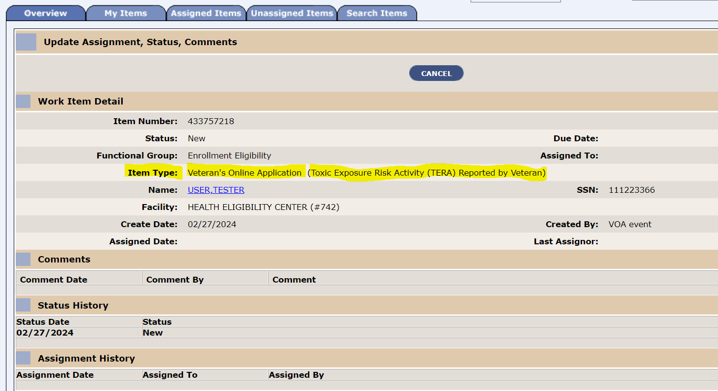

**Test Scenario# 2**

Applicant selects the following from VOA

No for cleanup data

No for Gulf War Hazard

Yes for Support Operation

Yes for Agent Orange

Selected the checkbox for below values:

Air Pollutants, Asbestos and Chemicals

SQA-A ICN: 0000001013992939V381726000000

**Snippet of VOA Request received in VES**:

<ns0:specialFactors>

<ns0:agentOrangeInd>true</ns0:agentOrangeInd>

<ns0:envContaminantsInd>false</ns0:envContaminantsInd>

<ns0:campLejeuneInd>false</ns0:campLejeuneInd>

<ns0:radiationExposureInd>false</ns0:radiationExposureInd>

<ns0:supportOperationsInd>true</ns0:supportOperationsInd>

<ns0:toxicExposure>

<ns0:exposureCategories>

<ns0:exposureCategory>Air Pollutants</ns0:exposureCategory>

<ns0:exposureCategory>Chemicals</ns0:exposureCategory>

<ns0:exposureCategory>Asbestos</ns0:exposureCategory>

</ns0:exposureCategories>

<ns0:fromDate>02/2000</ns0:fromDate>

<ns0:toDate>12/2005</ns0:toDate>

</ns0:toxicExposure>

</ns0:specialFactors>

**Expected Result: PASS**

TERA Work item is created in VES.

**Test Scenario# 3**

Applicant selects NO for all the cohort fields.

SQA-A ICN: 0000001013992947V207001000000

**Snippet of VOA Request received in VES**:

<ns0:specialFactors>

<ns0:agentOrangeInd>false</ns0:agentOrangeInd>

<ns0:envContaminantsInd>false</ns0:envContaminantsInd>

<ns0:campLejeuneInd>false</ns0:campLejeuneInd>

<ns0:radiationExposureInd>false</ns0:radiationExposureInd>

<ns0:supportOperationsInd>false</ns0:supportOperationsInd>

</ns0:specialFactors>

**Expected Result**: **PASS**

**No work item** created on VES.

**Test Scenario# 4**

Set TERA Ind = YES from VOA, no categories selected

**Snippet of VOA Request received in VES**:

SQA-A ICN: 0000001013992956V739665000000

<ns0:specialFactors>

<ns0:agentOrangeInd>false</ns0:agentOrangeInd>

<ns0:envContaminantsInd>false</ns0:envContaminantsInd>

<ns0:campLejeuneInd>false</ns0:campLejeuneInd>

<ns0:radiationExposureInd>false</ns0:radiationExposureInd>

<ns0:supportOperationsInd>false</ns0:supportOperationsInd>

</ns0:specialFactors>

**Expected Result**: **PASS**

**No work item** created on VES.

**Test Scenario# 5**

Applicants select YES on cohort #1 & 2. but do not enter dates for cohort #1 & 2.

Cohort#2: Gulf War Hazard = Yes. No dates entered.

Cohort#1: Select exposure category = OTHER. VOA allows max 100 alphanumeric char to be entered for other text. Leaving dates as blank

SQA-A ICN: 0000001013992981V162978000000

**Snippet of VOA Request received in VES**:

<ns0:specialFactors>

<ns0:agentOrangeInd>false</ns0:agentOrangeInd>

<ns0:envContaminantsInd>false</ns0:envContaminantsInd>

<ns0:campLejeuneInd>false</ns0:campLejeuneInd>

<ns0:radiationExposureInd>false</ns0:radiationExposureInd>

<ns0:gulfWarHazard>

<ns0:gulfWarHazardInd>true</ns0:gulfWarHazardInd>

</ns0:gulfWarHazard>

<ns0:supportOperationsInd>false</ns0:supportOperationsInd>

<ns0:toxicExposure>

<ns0:exposureCategories>

<ns0:exposureCategory>Other</ns0:exposureCategory>

</ns0:exposureCategories>

<ns0:otherText>enteringmorethan100charactersenteringmorethan100charactersenteringmorethan100charactersenteringmoret</ns0:otherText>

</ns0:toxicExposure>

</ns0:specialFactors>

**Expected Result: PASS**

TERA Work item is created in VES.

## VES 6.8.2 OTST Demo conducted on 2/28/2024.

**Test Scenario# 6**

Applicant enters the following from VOA app.

Gulf war Hazard = No

Support Operations = No

Exposure Category checkbox for Radiation, SHAD and Other.

Entered Other text field. Enter the date fields in mm/yyyy format.

SQA-A ICN: 0000001013993395V218349000000

**Snippet of VOA Request received in VES**:

<ns0:specialFactors>

<ns0:agentOrangeInd>false</ns0:agentOrangeInd>

<ns0:envContaminantsInd>false</ns0:envContaminantsInd>

<ns0:campLejeuneInd>false</ns0:campLejeuneInd>

<ns0:radiationExposureInd>false</ns0:radiationExposureInd>

<ns0:supportOperationsInd>false</ns0:supportOperationsInd>

<ns0:toxicExposure>

<ns0:exposureCategories>

<ns0:exposureCategory>Radiation</ns0:exposureCategory>

<ns0:exposureCategory>SHAD</ns0:exposureCategory>

<ns0:exposureCategory>Other</ns0:exposureCategory>

</ns0:exposureCategories>

<ns0:otherText>test</ns0:otherText>

<ns0:fromDate>06/2001</ns0:fromDate>

<ns0:toDate>04/2002</ns0:toDate>

</ns0:toxicExposure>

</ns0:specialFactors>

**Expected Result: PASS**

TERA Work item is created in VES.

**Test Scenario# 7**

This test was executed via SOAP UI, as VOA application is waiting to allow space for ‘Other’ text field.

Applicant selects Yes for Gulf War Hazard and enters the date fields in mm/yyyy format.

Selects Yes for Support Operations.

Selects the checkbox for exposure category as ‘Other’. Then enter ‘Other’ text field with alphanumeric char with spaces. Enters the date fields in mm/yyyy format.

SQA-A ICN: 0000001013993399V480963000000

**Snippet of VOA Request received in VES**:

 <ns0:specialFactors>  
<ns0:agentOrangeInd>false</ns0:agentOrangeInd>  
<ns0:envContaminantsInd>false</ns0:envContaminantsInd>  
<ns0:campLejeuneInd>false</ns0:campLejeuneInd>  
<ns0:radiationExposureInd>false</ns0:radiationExposureInd>  
<ns0:gulfWarHazard>  
<ns0:gulfWarHazardInd>true</ns0:gulfWarHazardInd>  
<ns0:fromDate>08/1990</ns0:fromDate>  
<ns0:toDate>09/1990</ns0:toDate>  
</ns0:gulfWarHazard>  
<ns0:supportOperationsInd>true</ns0:supportOperationsInd>  
<ns0:toxicExposure>  
<ns0:exposureCategories>  
<ns0:exposureCategory>Other</ns0:exposureCategory>  
</ns0:exposureCategories>  
<ns0:otherText>  Test1234 space12233 s   betw een  </ns0:otherText>  
<ns0:fromDate>01/2000</ns0:fromDate>  
<ns0:toDate>01/2010</ns0:toDate>  
</ns0:toxicExposure>  
</ns0:specialFactors>

**Expected Result: PASS**

TERA Work item is created in VES.

**Test Scenario# 8**

Applicant selects ‘Other’ exposure category. Other Text field is left BLANK from VOA.

**NOTE**: VOA team will be adding a validation on their UI to make the ‘Other’ text field as required when an applicant selects Exposure category as ‘Other’. This will be tested after their deployment is complete.

**Expected Result: <Awaiting additional test>**

VES will ignore this VOA request. No work item will be created on VES.